Project Design Phase
Solution Architecture

Date | 15 February 2025
Team ID | LTVIP2026TMIDS76805
Project Name | Online Payments Fraud Detection using Machine Learning
Maximum Marks | 4 Marks

Solution Architecture:
Solution architecture bridges the gap between the business problem (online payment fraud) and the technical implementation (Machine Learning fraud detection system).
The goals of the solution architecture are:
● Identify the most suitable Machine Learning and web technologies to detect fraudulent transactions in real-time.
● Describe the structure, workflow, and data flow of the fraud detection system to stakeholders.
● Define system features such as user input, fraud prediction, probability scoring, and alert mechanisms.
● Provide technical specifications for development, deployment, and system management.

Example - Solution Architecture Diagram:

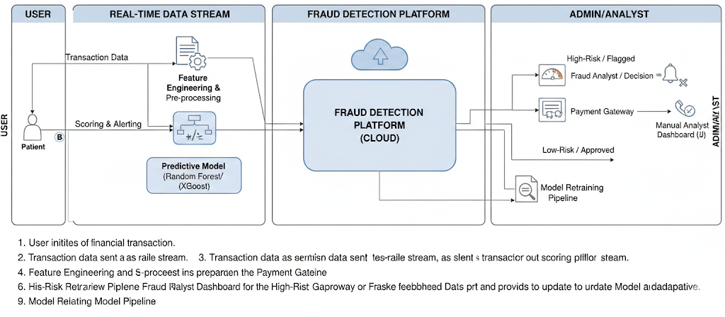
Figure 1: Architecture and Data Flow of Online Payments Fraud Detection System

